EYFS Lead/  Teacher | Teacher | Teaching Assistants across EYFS
 | 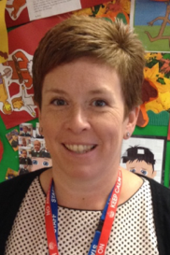 | 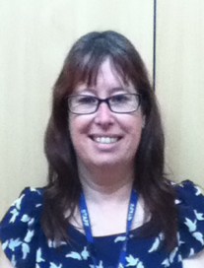 | 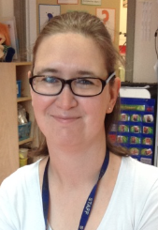 |  | 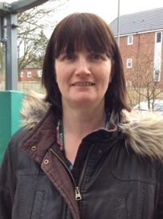
Miss Smith | Mrs Robson | Mrs Duff | Miss Long | Mrs Sanderson | Mrs Green
Staff: children ratio  Children aged 2-3 years 1 staff 4 children  Children aged 3-4 years 1 staff 8 children |  |  |  | 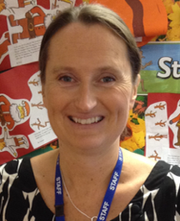 | 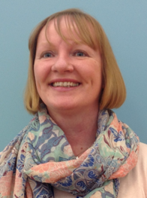
 |  |  |  | Mrs Kennedy | Miss Machers

