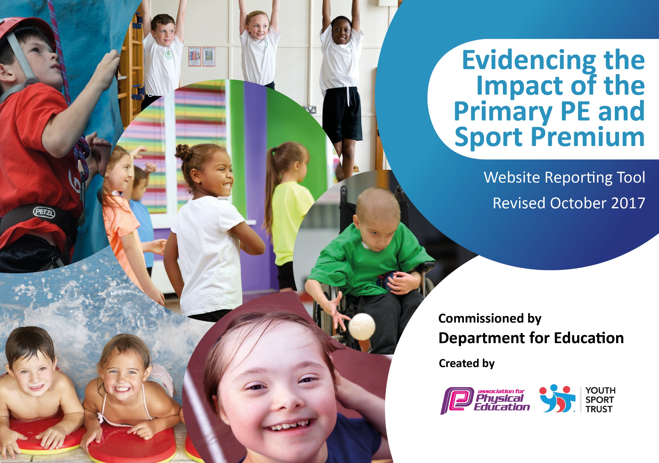

Physical Education at New Delaval Primary School – Our Vision:

At New Delaval Primary School, we believe that physical education is a fundamental component of a child’s educational development. We aim to develop a varied and engaging PE curriculum, which both enthuses children and supports their critical physical development. As children move through school,they will flourish due to the clear progression of skills; leading to confident and skilled sports players. Furthermore, we will promote an inclusive approach to PE, whereby allpupils will be enabled to participate in competitive sport. We will encourage children to attendextra-curricular sports clubs and participate in competitions, which will promote an understanding of a healthy lifestyle. Gifted and talented children will be afforded extra opportunities to compete and will be challenged further to maximize their personal sporting development. Integral to our PE curriculum will be the promotion of values including: determination, passion, respect, honesty, self-belief and team-work. Ultimately, throughout the school community, in partnership with the Northumberland Sports Service, we aim to nurturea true passion for sport.

Since 2013, the government has provided additional funding each academic year to improve provision of physical education (PE) and sport in primary schools. This funding - provided jointly by the Departments for Education, Health and Culture, Media and Sport - will be allocated to primary schools again this year. The document below outlines how we plan to spend our sports funding and the impact it will have on the children of New Delaval Primary School.

Support for review and reflection - considering the 5 key indicators from DfE, what development needs are a priority for your setting and your students now and why? Use the space below to reflect on previous spend, identify current need and priorities for the future.

Key achievements to date: | Areas for further improvement and baseline evidence of need:
- Year 5 and 6 Sports Leaders Programme  - KS2 boys football training and team  - Links with the Northumberland sports partnership and key  teacher Angela Parsons  - Cycling initiatives within school | - Engagement of all groups of pupils in extra-curricular and competitive sport (particularly girls)  - Promotion of enthusiasm for achievement in sport  - A more accurate assessment system to identify different ability groups in P.E.

Meeting national curriculum requirements for swimming and water safety | Please complete all of the below:
What percentage of your Year 6 pupils could swim competently, confidently and proficiently over a distance of at least 25 metres when they left your primary school at the end of last academic year? | 80%
What percentage of your Year 6 pupils could use a range of strokes effectively [for example, front crawl, backstroke and breaststroke] when they left your primary school at the end of last academic year? | 80%
What percentage of your Year 6 pupils could perform safe self-rescue in different water-based situations when they left your primary school at the end of last academic year? | N/A
SchoolscanchoosetousethePrimaryPEandSportPremiumtoprovideadditionalprovisionforswimming but this must be for activity over and above the national curriculum requirements. Have you used it in this way? | No

Action Plan and Budget Tracking
Capture your intended annual spend against the 5 key indicators. Clarify the success criteria and evidence of impact that you intend to measure to evaluate for students today and for the future.

Academic Year: 2018/2019 | Total fund allocated: £17,630 | Date Updated: November 2018
Key indicator 1: The engagement of all pupils in regular physical activity – Chief Medical Officer guidelines recommend that primary school children undertake at least 30 minutes of physical activity a day in school |  |  |  | Percentage of total allocation:
 |  |  |  | 10%
School focus with clarity on intended impact on pupils: | Actions to achieve: | Funding allocated: | Evidence and impact: | Sustainability and suggested next steps:
All children to be involved in regular physical activity and promotion of sport beyond the core curriculum. | - Extra-curricular clubs to target girls  - Continue the sports leadership programme  - All KS2 groups to have professional coaching as part of their P.E. lessons.  - Additional physical activity built into each day. – Jump start Johnny, Daily mile and early yoga. | Newcastle Eagles £210  Dance City £400  NUFC £400 | Girls’ football club during Autumn term 2018. Entered local competition and reached the semi-finals.  Cheerleading club during autumn term to appeal to girls. All places were filled.  Sports Leaders in year 6 have continued their role and 10 new sports leaders have been successfully trained in year 5.  Local sports organisations working with KS2 classes:  Yr6 Newcastle Eagles  Yr5 Dance City  Yr4 Newcastle Falcons  Yr3 NUFC
Key indicator 2: The profile of PE and sport being raised across the school as a tool for whole school improvement |  |  |  | Percentage of total allocation:
 |  |  |  | 10%
School focus with clarity on intended impact on pupils: | Actions to achieve: | Funding allocated: | Evidence and impact: | Sustainability and suggested next steps:
To promote an interest in a range of sports.  To link values in sport with behaviour outcomes. | - Send a questionnaire to parents to assess interest in extra-curricular clubs (data on preferred sports and days)  - Organise an assembly with an athlete/sportsperson  - Order new kit for competitions  - Link values in P.E. teaching with behaviour values in school.  - P.E. equipment to be ordered as required. | £1000 for sports coaches  Cost of new kit £500  Cost of equipment  £600  Cost of values stickers  £30  £500 | A questionnaire was sent out to parents in the autumn term. The data was analysed and dodgeball, running and tennis clubs are to be implemented as a result.  Participation in former national/Olympic player) to work with KS2 .  A tracksuit for competitions with the school logo has been ordered.  Stickers with P.E. values on.  Equipment to be ordered this year:  Netball kit, tennis equipment, bikes

Key indicator 3: Increased confidence, knowledge and skills of all staff in teaching PE and sport |  |  |  | Percentage of total allocation:
 |  |  |  | 10%
School focus with clarity on intended  impact on pupils: | Actions to achieve: | Funding  allocated: | Evidence and impact: | Sustainability and suggested  next steps:
All staff to be confident in teaching P.E. so that children experience strong teaching in this subject and teachers impart beneficial knowledge and skills. | - Audit of staff needs in relation to the P.E. curriculum  - Observe professional coaching to upskill and improve knowledge  - CPD opportunities as required | Cost of any CPD tbc. Throughout the course of the year  £1500 | P Struthers to complete FA football coaching level 1 course.  KS2 staff to observe professional coaches working with their classes.
Key indicator 4: Broader experience of a range of sports and activities offered to all pupils |  |  |  | Percentage of total allocation:
 |  |  |  | 10%
School focus with clarity on intended  impact on pupils: | Actions to achieve: | Funding  allocated: | Evidence and impact: | Sustainability and suggested  next steps:
Improve the range of sports offered throughout school, so that children are more enthused by sport and have varied opportunities.  Ensure each child has a suitable PE/team kit to wear during sporting events. | - Audit the current offering across year groups through curriculum planning.  - Offer outdoor activity sessions for year 5. Links to be made with a local organisation.  - Establish a link with an external provider for a KS1 after school club.  - Continue relationship with Cycle Generation to provide cycling opportunities for children.  - High Borrans activity residential for Y6 summer term.  - Kayaking and paddle boarding for Y5 session  Purchase new kit for children as and when they require a larger size. | Cost nil  £4,500  £500  -£500An increased number of children can now attend these residential trips, where as in the past they would miss out, due to cost. | Half termly bike rides for KS2 children.  Children experiencing  - An increased number of children can now attend these residential trips, where as in the past they would miss out, due to cost.  All children have a PE kit that they can wear during lessons.
Key indicator 5: Increased participation in competitive sport |  |  |  | Percentage of total allocation:
 |  |  |  | 60%
School focus with clarity on intended  impact on pupils: | Actions to achieve: | Funding  allocated: | Evidence and impact: | Sustainability and suggested  next steps:
Ensure that competitive sport opportunities are promoted within school for all pupils. | - Each year group to attend a sporting competition over the course of the year, as part of the Northumberland sports partnership schedule.  - Boys’ football team to participate in the football league.  - Gifted and talented children to be identified through new assessment system and entered into more than one competition during the course of the year. | £10,000  Allocated cost for involvement with BSSPSports | Competitions attended this year to date:  YR2 multi skills 09/17  YR6 new age bowling 10/17  YR 5/6 Tag Rugby 10/17  YR 5/6 football 11/17  Boys’ football matches throughout autumn term.

