

Phonics

If you want to find out how to support your child at home look inside for Top Tips!

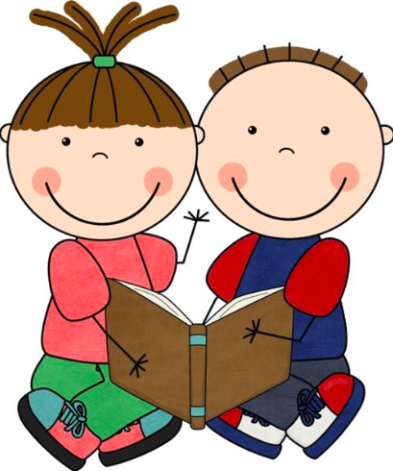

Parents Information:

When beginning to read and write children need to be able to sound out words, they slowly say each sound in a word (c-a-t), and then say the sounds quickly together to "read" the word (cat).

In reading, teachers call this blending because sounds are being blended together. Blending (combining sounds) and segmenting (separating sounds) are skills that are necessary for learning to read and write.

Developing a child's sound awareness is an important part of developing a reader and writer.

We would love to see any pictures, writing and photographs of you and your child playing these games together.

Thank you for your ongoing support!

Top Tips and Games for you and your child:

1. Guess the Word

**Activity**: Place a small number of picture cards in front of your child. Tell them you are going to say a word using "Snail Talk" a slow way of saying words (e.g., /fffffllllaaaag/). They have to look at the pictures and guess the word you are saying. Get your child to find the picture and have a go at doing “Snail Talk” themselves.

Pictures are at the back of this booklet.

Your child could then become the teacher and “Snail Talk” words for you to find.

1. Robot Talk

**Activity**: Talking in "Robot Talk" have picture cards in front of your child, then “Robot Talk” the word (e.g. c – a –t ) the child then has to find the picture, and they could have a go at writing it down! See if your child can identify the first sound ( c ) the middle sound ( a ) and the sound at the end ( t ).

Pictures are at the back of this booklet.

1. Sound blending using songs

**Activity**: Sing to the tune of "*If You're Happy and You Know It, Clap Your Hands*."

“If you think you know this word, shout it out!

If you think you know this word, shout it out!

If you think you know this word,

Then tell me what you've heard,

If you think you know this word, shout it out!

After singing, say a segmented word /c/ /a/ /t/ and your child shouts "cat!”, finds the picture or writes it down to tell you the answer.

Pictures are at the back of this booklet.

1. Blending Slide / Car Racing

**Activity**: Write some simple words (cat, sat, pat) down the slide, get your child to run their finger down the slide and blend the sounds together. OR you could put a picture at the bottom of the slide, your child has to use “Robot Talk” to figure out which sounds are needed to write the word, then write them down the slide. You can play this same game using the racing car track – the child can run their toy car across the road and say the sounds they see OR place a picture at the end of the track and they have to write the sounds in the boxes.

Slide at the back of this booklet. Race track at the back of this booklet. You will need a small toy car.

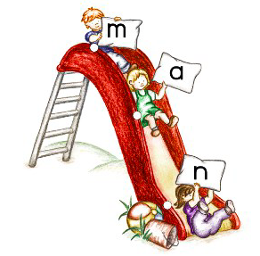

1. Doggie Where’s My Bone?

**Activity**: Tell your child “I’m going to say a word and then a sound in the word. If the sound is at the beginning of the word, place the bone on the head of the dog. If the sound is in the middle of the word, place the bone on the body. If the sound is at the end of the word, put the bone on the tail. Here is the first word “bat - /t/” “ To support your child point to the boxes as you separate the word.

Dog at the back of this booklet. You will need a ‘bone’ to use.

1. Breaking up Words

**Activity**: Look at the pictures and sound buttons at the back of this booklet. Your child has to look at the picture and push the sound buttons to sound out the word.

|  |  |
| --- | --- |
| /Users/charlottesmith/Desktop/Screen Shot 2016-09-29 at 19.24.04.png |  |

Resources:

Pictures and words to cut out:

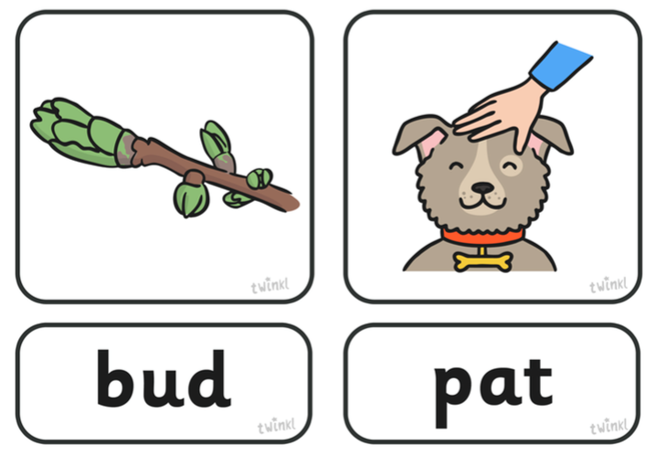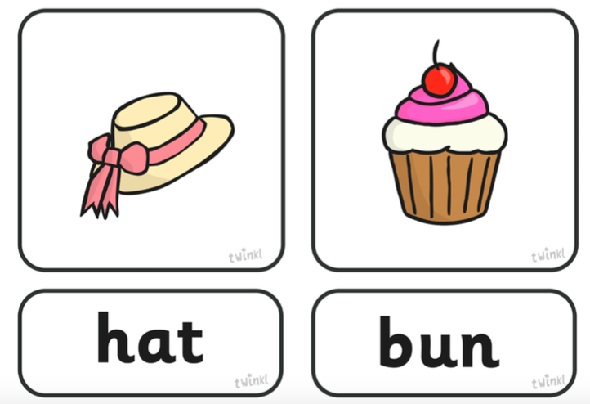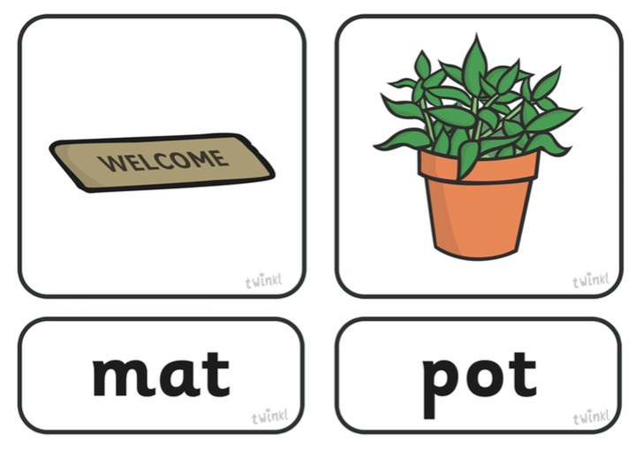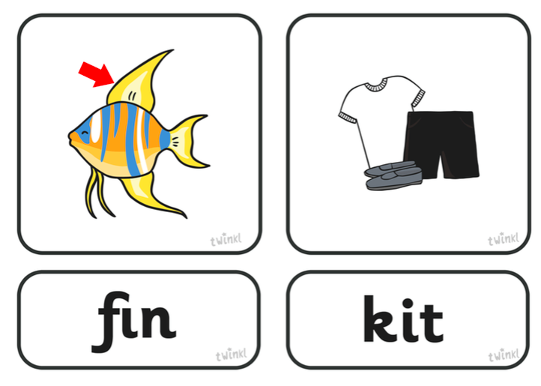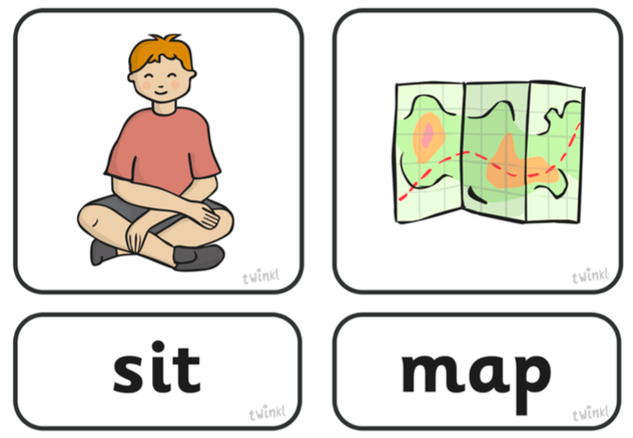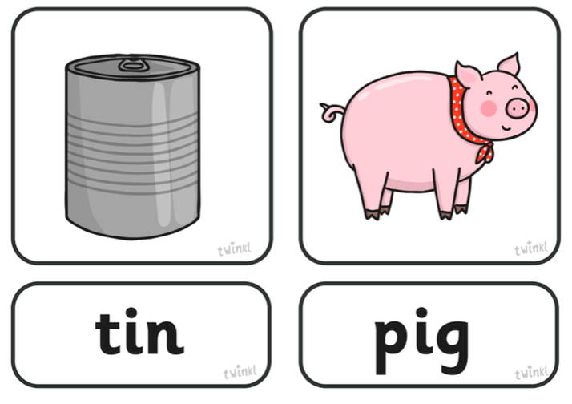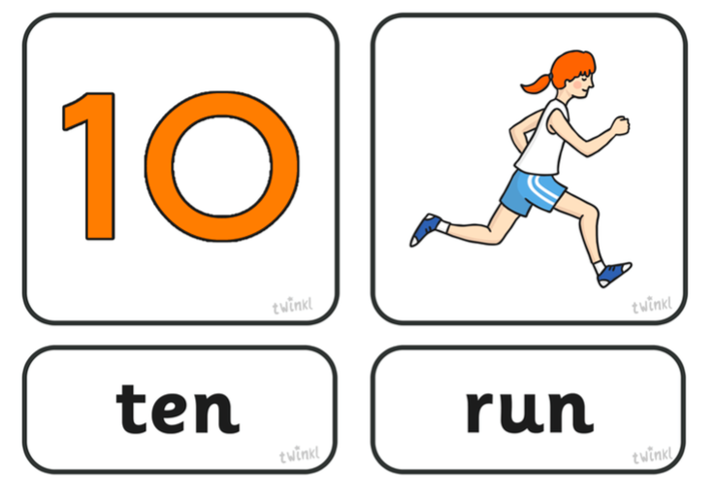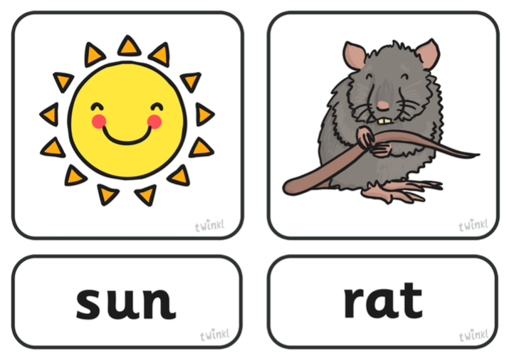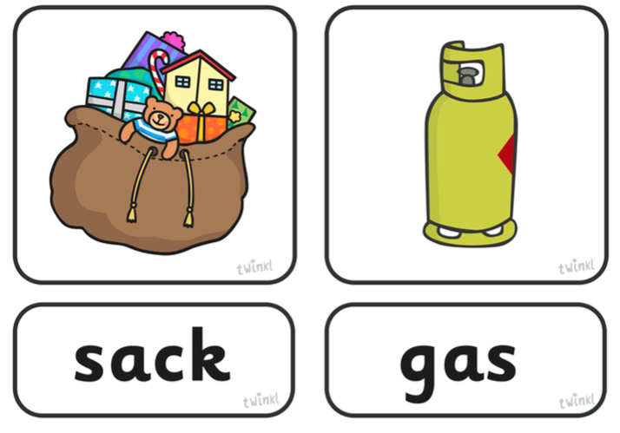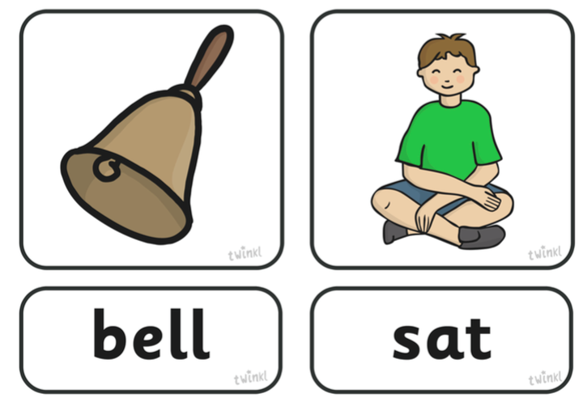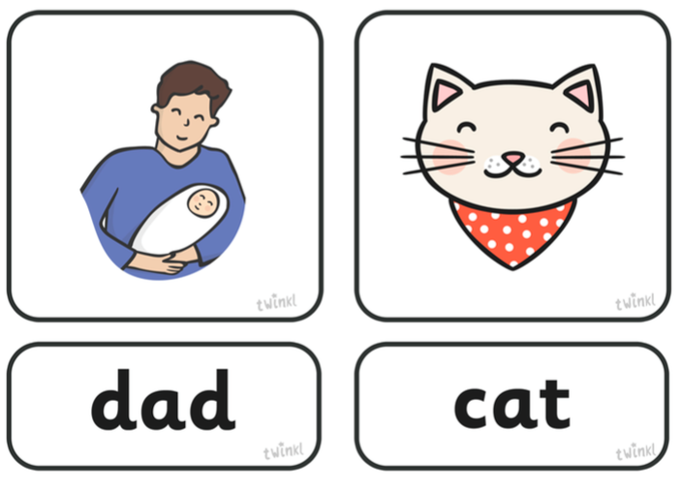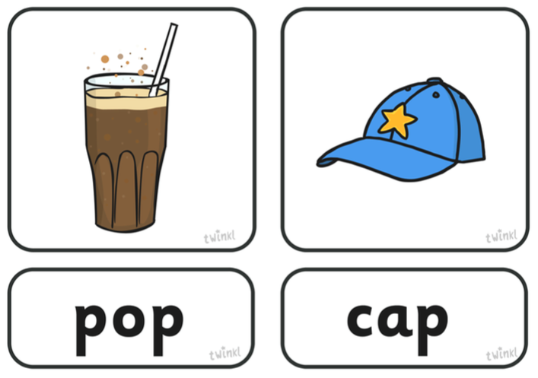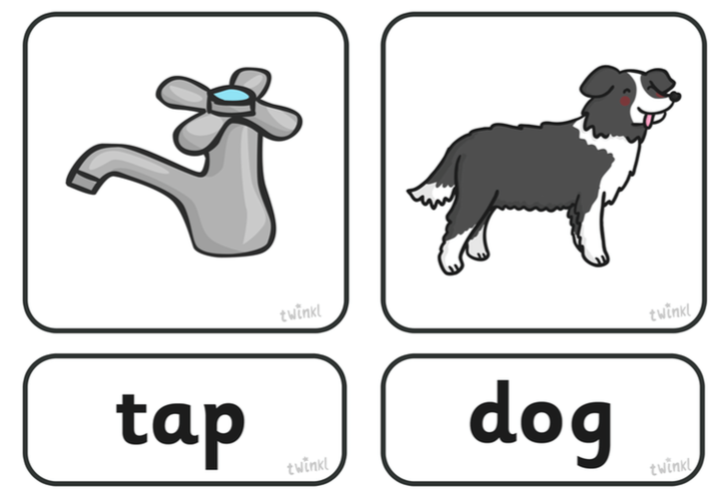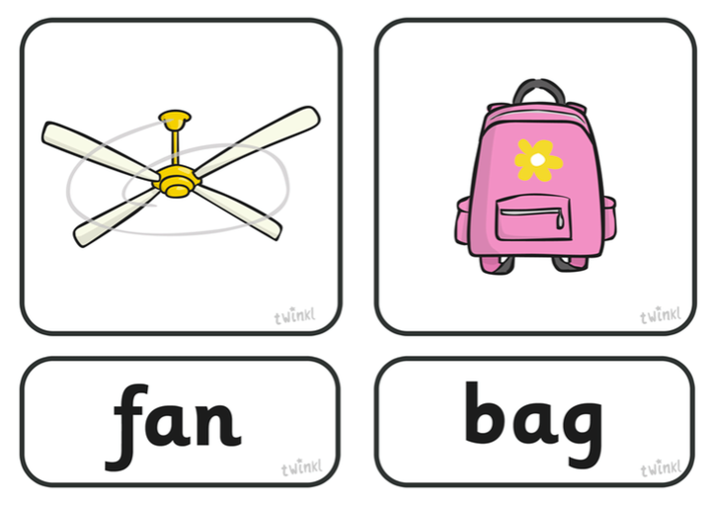

Blending Slide

|  |  |
| --- | --- |
|  |  |

Breaking Up Words – place one of the pictures in the empty boxes.

|  |  |
| --- | --- |
|  |  |
|  |  |
|  |  |
|  |  |
|  |  |

|  |  |
| --- | --- |
|  |  |

Doggie Where’s My Bone? And Car Racing

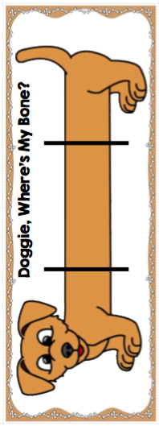



Start

Finish